ANALYSIS ON INTERNATIONAL AIR TRAFFIC IN AND OUT OF INDIA

**A PROJECT REPORT**

**Submitted by**

**SREEKA. G (21ADR051)**

**KAVILA. V (21ADR021)**

**NITHISH. K (21ADR032)**

**SANTHOSH. S (21ADR067)**

***for***

# 20ADC33 DATA ANALYSIS

# DEPARTMENT OF ARTIFICIAL INTELLIGENCE



**KONGU ENGINEERING COLLEGE**

# (Autonomous)

**PERUNDURAI ERODE – 638 060**

# DECEMBER 2022

**KONGU ENGINEERING COLLEGE**

**(Autonomous)**

**PERUNDURAI ERODE – 638 060**

**DECEMBER 2022**

Department of Artificial Intelligence

20ADC33 – Data Analysis Project Report

Signature of course in-charge Signature of the HOD

Submitted for the continuous Assessment viva voice examination held on __ _

**EXAMINER I EXAMINER II**

# ABSTRACT

According to a research from the last three years, the aviation business in India is now an industry that is rapidly expanding on the surface. India is now the third-largest domestic aviation market in the world, and by the end of 2024, it is predicted to overtake China as the third-largest air passenger market. The Government of India is aiming to increase the number of airports in order to meet the needs of travellers. India is predicted to have 103 operating airports in 2019 along with a significant growth in the number of aircraft. The Indian government intends to increase its investments in the aviation industry through a number of different initiatives.India presently has 91 international airlines, comprising 5 domestic carriers and 86 foreign carriers, which reflects the growth of the country's aviation sector. With this link to important international markets, domestic airline demand grew by 18.6% in revenue passenger kilometres in 2018, which is three times the worldwide RPK increase of 6.5%.

IAA oversees about 78% of domestic passenger traffic and 22% of international passenger traffic from 125 airports and runways out of a total of 464. The percentage of cargo traffic that contributed to economic growth was greater, at 68.5% for international cargo and 31.5% for domestic freight. Along with this, yearly growth in maintenance and repair is anticipated. Major accomplishments like the IGI airport in Delhi, which has the highest and most modern air traffic control tower, increase safety and the effectiveness of air transport management services. As a result, with a contribution to GDP of 72, the Indian aviation industry is the largest contributor to the Indian economy. By fostering globalisation, where the number of travellers rose from 79 million in 2010 to 158 million in 2017, it indirectly supports the economy.

# TABLE OF CONTENTS

|  |  |  |
| --- | --- | --- |
| **CHAPTER**  **No.** | **TITLE** | **PAGE NO.** |
|  | **ABSTRACT** | 3 |
| 1. | **INTRODUCTION** | 5 |
|  | 1.1 INTRODUCTION | 5 |
|  | 1.1.1 DATA COLLECTION | 5 |
|  | 1.2 PROBLEM STATEMENT | 7 |
|  | 1.3 BUSINESS OBJECTIVE | 7 |
| **2.** | **DATA PREPARATION AND MODELING** | 8 |
|  | 2.1 DATA CLEANING | 8 |
|  | 2.2 DATA TRANSFORMATION | 8 |
|  | 2.3 DATA DISTRIBUTION USING CHARTS | 17 |
|  | 2.4 DATA MODELLING | 17 |
| **3.** | **DATA ANALYSIS AND INTERPRETATION** | 18 |
|  | 3.1 DATA ANALYSIS | 18 |
|  | 3.2 PUBLISHING DASBOARDS | 42 |
|  | 3.3 INFERENCE | 44 |
| **4.** | **CONCLUSION** | 45 |
| **5.** | **REFERENCES** | 46 |

# CHAPTER 1

# INTRODUCTION

## INTRODUCTION

The Indian aviation industry has a lengthy history and has been controlled by both the public and commercial sectors at various points. The industry has seen traffic flow in both the passenger and freight segments significantly improve with each passing year. India ranks ninth in terms of market size in the 2017 India Brand Equity Survey Report. Domestic passenger traffic in the nation increased by 21.5% in the 2017 fiscal year.functioning airports: 66 domestic airports, 7 customs airports, and 17 international airports.

The level of life has significantly improved, and the advent of the economy class has also affected passengers' preferences. Prior to recently, only those of class would utilise airlines. Today's trends have evolved, enabling the general public to now travel by aeroplane. The amount of passengers has increased, which reflects this. Domestic passengers increased from 85.20 million in 2015–16 to 103.75 million in 2016–17. Additionally, the number of passengers travelling internationally climbed from 49.78 million in 2015–16 to 54.68 million in 2016–17. As a result, the sector that was formerly dominated mostly by government entities is now coexisting peacefully with private companies. The increasing market competitiveness benefits both on-air and ground transportation.

## 1.2DATA COLLECTION

The practise of obtaining data on certain variables designated as data needs is known as data collection. The need of ensuring accurate and truthful data collecting is highlighted. Data collection makes sure the information acquired is correct so that judgements made in connection with it are sound. Data collection offers a starting point for comparison and a goal for improvement. Here, the data is gathered from the DGCA, where it is gathered by the Indian government. The next level of this dataset offers information on the international air traffic to and from Indian territory from January 2015 to March 2017:

* ANALYSIS OF AIRLINE WISE
* ANALYSIS OF CITYPAIR WISE
* ANALYSIS OF COUNTRY WISE

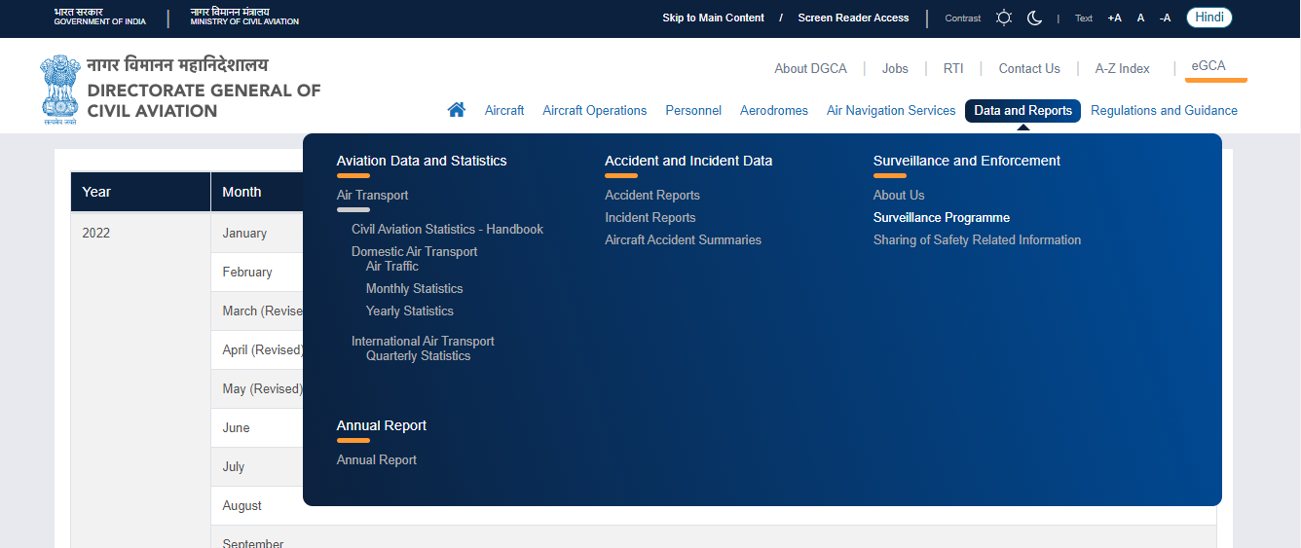

Figure 1.1 Data Collection

**DATASET:**

[**https://www.dgca.gov.in/digigov-portal/?page=monthlyStatistics/259/4751/html&main259/4184/servicename**](https://www.dgca.gov.in/digigov-portal/?page=monthlyStatistics/259/4751/html&main259/4184/servicename)

**DESCRIPTION OF DATASET:**

Airlinewise Monthly International Air Traffic To And From The Indian Territory

The variables are:

* YEAR
* MONTH
* QUARTER
* AIRLINE NAME
* CARRIER TYPE
* PASSENGERS TO INDIA
* PASSENGERS FROM INDIA
* FREIGHT TO INDIA
* FREIGHT FROM INDIA

Citypairwise Quarterly International Air Traffic To And From The Indian Territory

The variables are:

* YEAR
* MONTH
* QUARTER
* CITY1
* CITY2
* PASSENGERS FROM CITY1 TO CITY2
* PASSENGERS FROM CITY2 TO CITY1
* FREIGHT FROM CITY1 TO CITY2
* FREIGHT FROM CITY2 TO CITY1

Countrywise Quarterly International Air Traffic To And From The Indian Territory

The variables are:

* YEAR
* MONTH
* COUNTRY
* PASSENGERS TO INDIA
* PASSENGERS FROM INDIA
* FREIGHT TO INDIA
* FREIGHT FROM INDIA

Shows the data for the air traffic from 2015 to 2017. The data will be updated every quarters. The updated data will be notified by the government of India in the DGCA website.

This dashboard on International air traffic in and out of India will give insights about the air transportation within the country and outside the country. It gives clear visuals about the flights, People who migrated from one city to another city domestically and to the foreign countries.

This dashboard would help us to understand the Indian airline standards and clear view of the air transportation.

## PROBLEM STATEMENT

* Airport data is seasonal in nature, therefore any comparative analyses should be done on a period-over-period basis.
* This analysis is made to identify the total number of freights, passengers migrated from India to other countries and also within the domestic cities.
* This analysis helps to show case the annual reports of the Freights and passengers in and out of India.

## BUSINESS OBJECTIVE

* To Analyse the air transport in and across India
* To visualize the total passengers who travelled in both domestic and international flights.
* To visualize the freights and goods that were carried across the country.
* To give insights about the airline wise, country wise and city wise flights.

**CHAPTER 2**

**DATA PREPARATION AND MODELING**

**2.1 DATA CLEANING**

The practise of correcting or deleting inaccurate, damaged, improperly formatted, duplicate, or missing data from a dataset is known as data cleaning.

There are several ways for data to be duplicated or incorrectly categorized when merging different data sources.

Even though results and algorithms appear to be right, they are unreliable if the data is inaccurate.

Because the procedures will differ from dataset to dataset, there is no one definitive way to specify the precise phases in the data cleaning process.

But it is essential to create a template for your data cleaning procedure so you can be sure you are carrying it out correctly each time.

**2.2DATA TRANSFORMATION**

This method is used to change the data into formats that are appropriate for the mining process. This entails the following:

* NORMALIZATION
* ATTRIBUTE SELECTION
* DISCREATION
* CONCEPT HEIRACHY LEVEL

**DATA PROCESSING:**

Data manipulation by a computer is known as data processing. Data flow via the CPU and memory to output devices, formatting or modification of output, and conversion of raw data to machine-readable form are all included.

We used data sources for 2015-2017 air traffic data thata re freely available in the internet. Get started on how to create dash board in PowerBI with airtraffic dataset.

There are 3 Excel files consisting of various information of the air traffic.

**DATA PREPARING:**

When data is first acquired, it has to be organised or processed before analysis. These, for instance, can entail organising data into rows and columns in a table style (known as structured data) for later analysis, sometimes with the use of statistical or spreadsheet software.

STEP1 :

The dataset is first loaded from to POWER BI file for further processing and visualisation.

STEP2:

Then go to DATA view and then in the home tab select the TRANSFORM DATA and load all the four data tables into int for pre-processing and modelling.

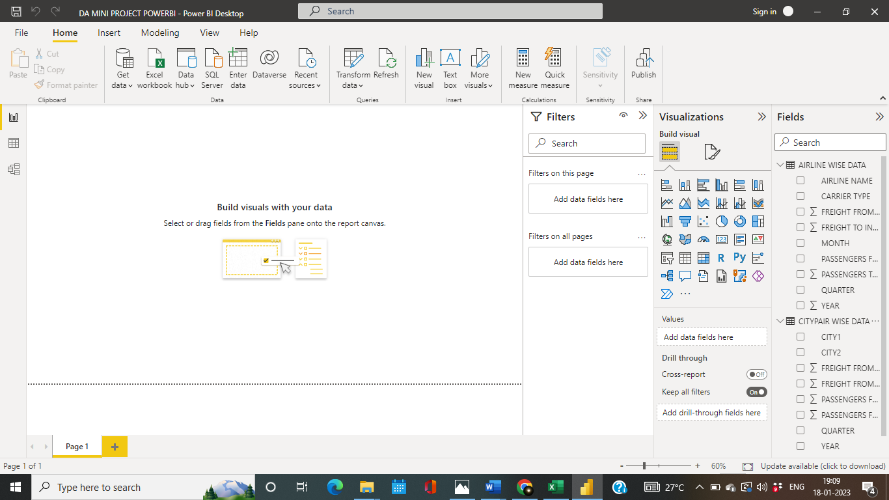

Figure 2.1 Transform data

### **STEP3:**

**S**elect Home > Use First Row as Headings to elevate the first row to column headers. Select Home, then the arrow next to Use First Row as Headers, and finally select Use Headers as First Row to drop column headers to the first row.

**STEP 4:**

Download the dataset from DGCA.

**OUTPUT**

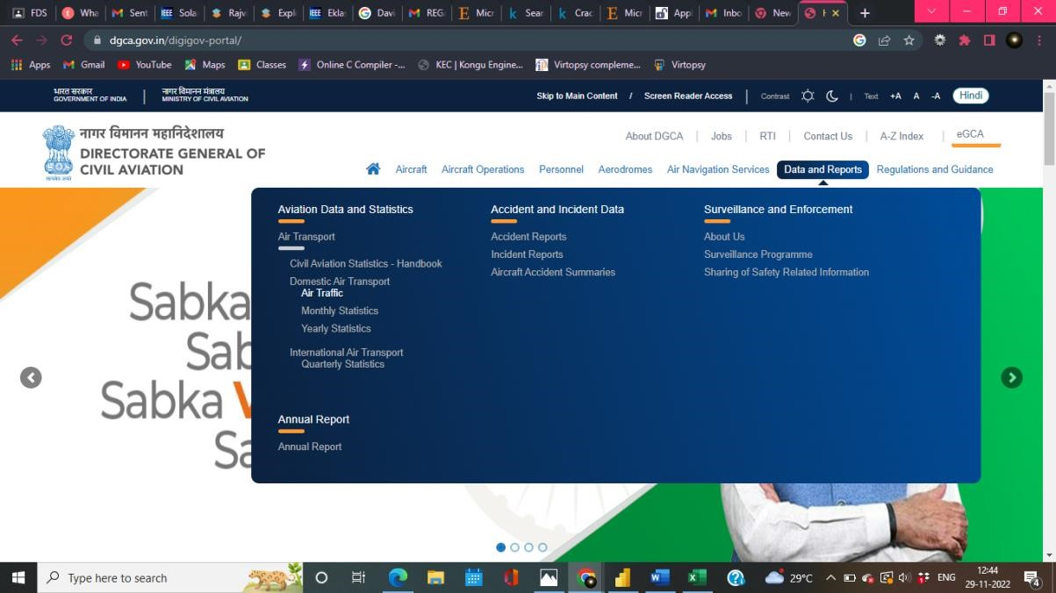

Figure 2.2 Dataset download

Before loading the datasets into the power BI the null values are removed in the excel.

Excel→find&select→go to special→select blank→delete the rows which has null values.

**OUTPUT**:

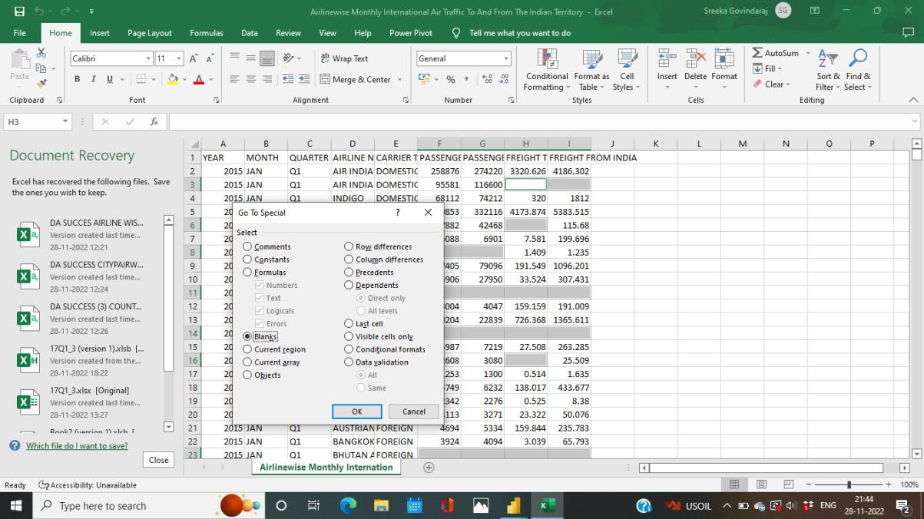

Figure 2.3 Removing Null Values

**STEP 5:**

The datasets of AIRLINE WISE,CITYPAIR WISE,COUNTRY PAIRWISE tables were loaded in the power BI.

**OUTPUT**:

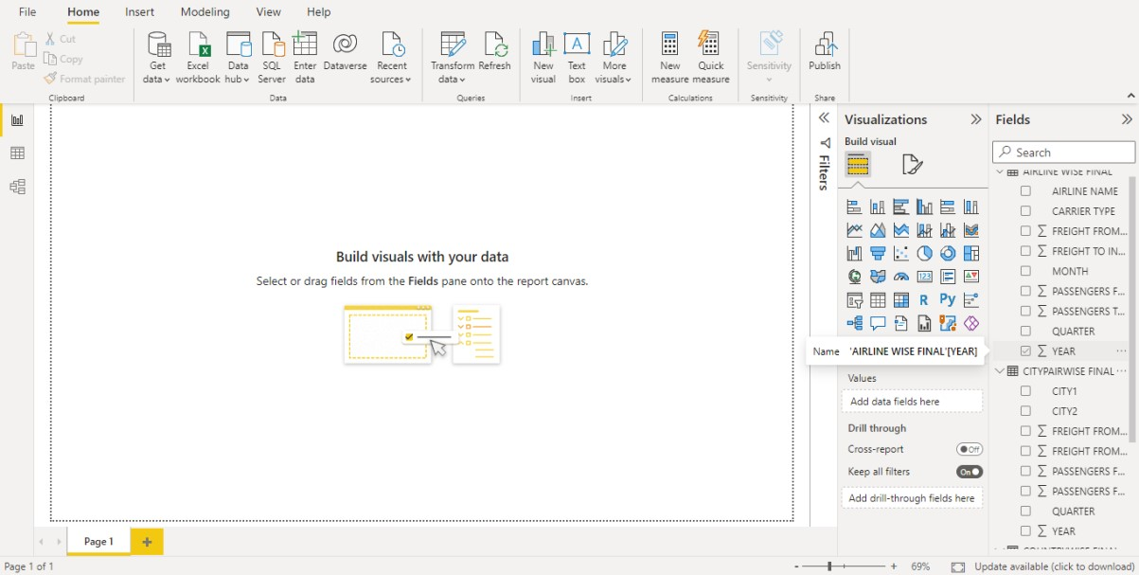

Figure 2.4 Transform data

**STEP** 6:

In order to do manipulations in the dataset in the Home tab click on the transform data tab and the required manipulations can be done in the transform tab.

Home→Transform tab

**STEP** 7:

Rename the CITYPAIRWISE FINAL→CITY PAIRWISE DATA

COUNTRY WISE FINAL→COUNTRY WISE DATA **OUTPUT**:

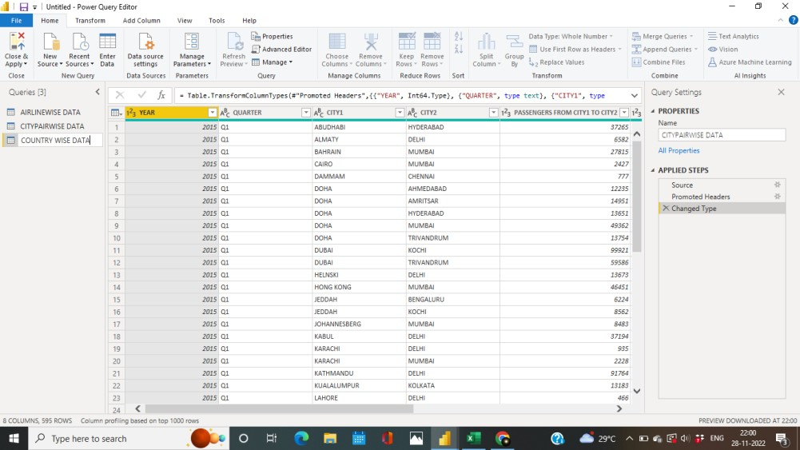

Figure 2.5 Rename

**STEP** 8:

From the “PASSENGERS TO INDIA “ column, remove the records which have ‘0’ values using the filters in the transform tab. The records with 0 values can be removed from the dataset as they make the data more futile.

Follow the same procedure for “PASSENGERS FROM INDIA” from all the three datasets.

**OUTPUT**:

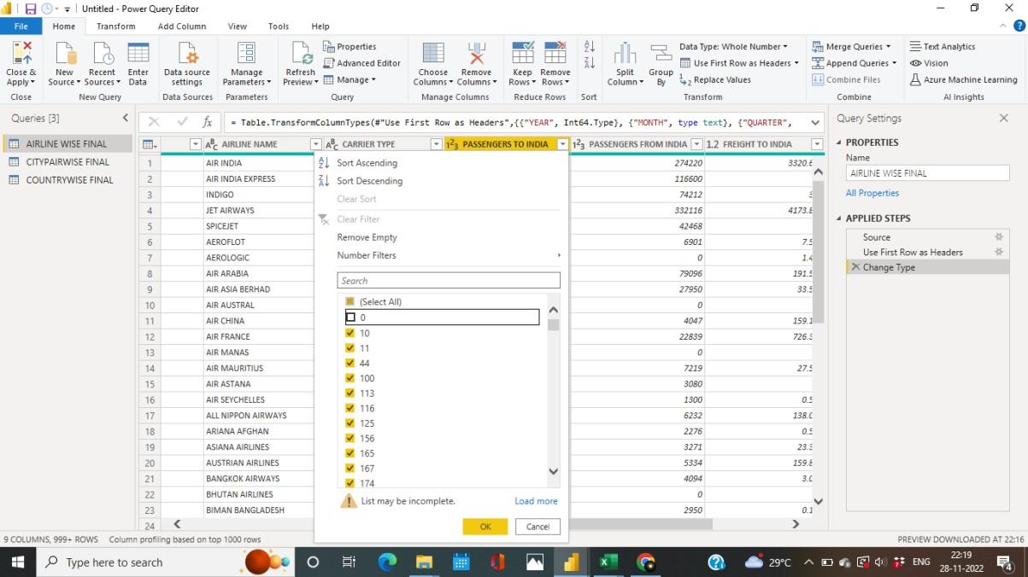

Figure 2.6 Remove Blank values

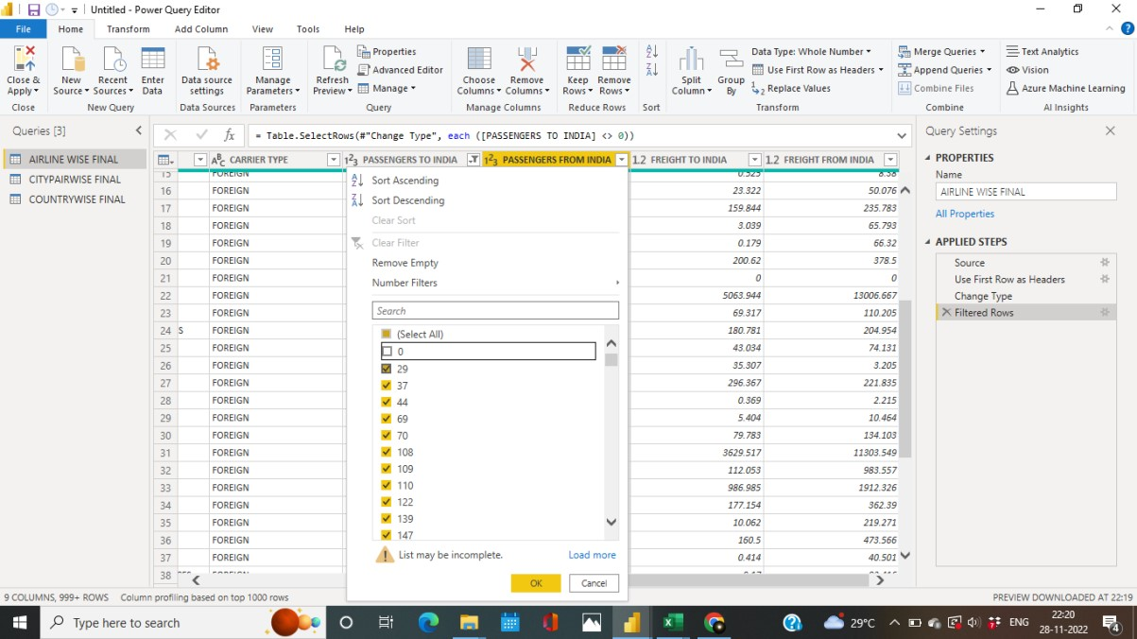

Figure 2.7 Removing 0 values

**STEP 9:**

In the “Freight to India” column change the type from decimal to whole number in all the three datasets.

**OUTPUT**:

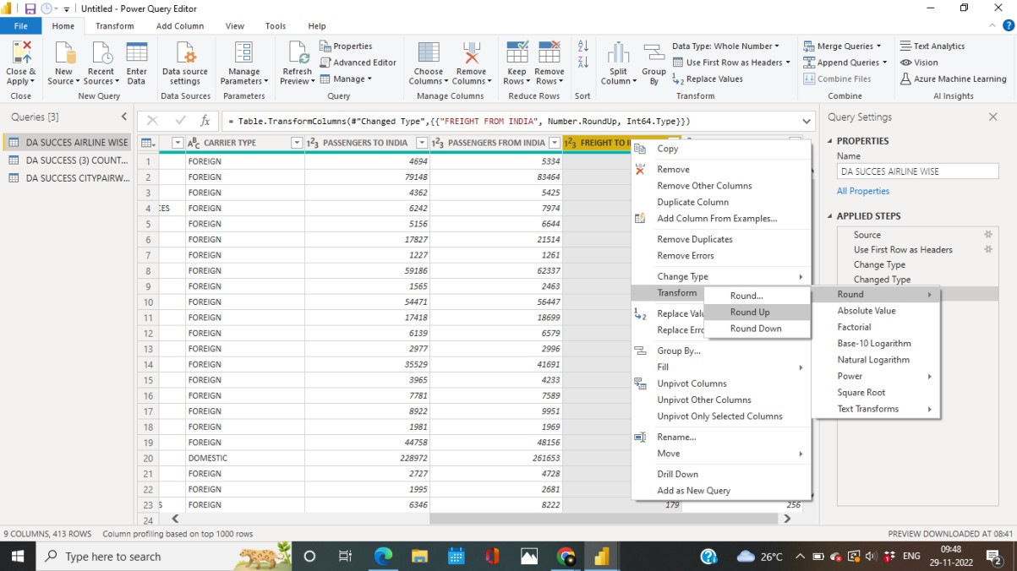

Figure 2.8 Change Type

In the “Freight from India” column change the type from decimal to whole number in all the three datasets.

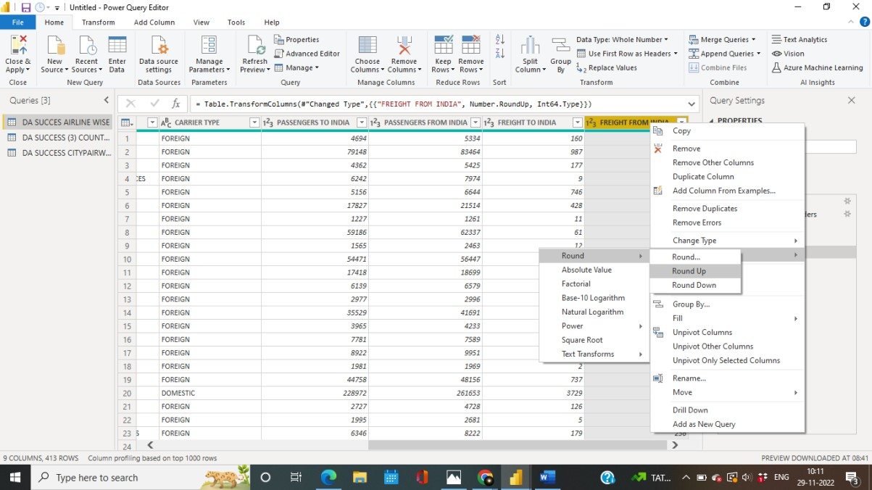

Figure 2.9 Change Type

**STEP 10:**

In the Home tab go to the open the merge queries tab. Now Merge the “PASSENGERS FROM INDIA” in Airline wise data and Country wise data. **OUTPUT**:

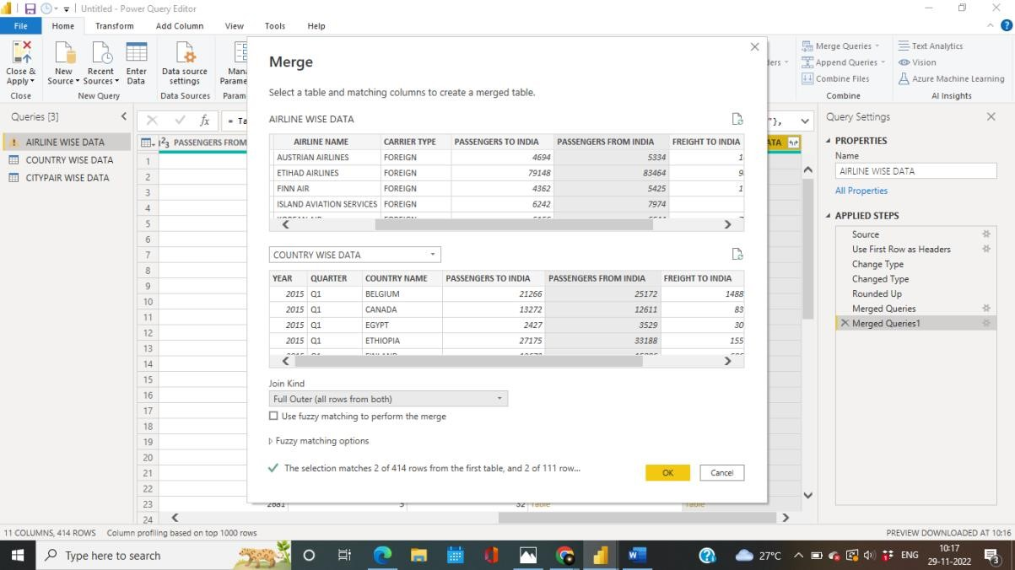

Figure 2.10 Merge Queries

**STEP 11:**

In the merge queries tab merge the “YEAR” from the country wise data and city pair wise data.

**OUT PUT**:

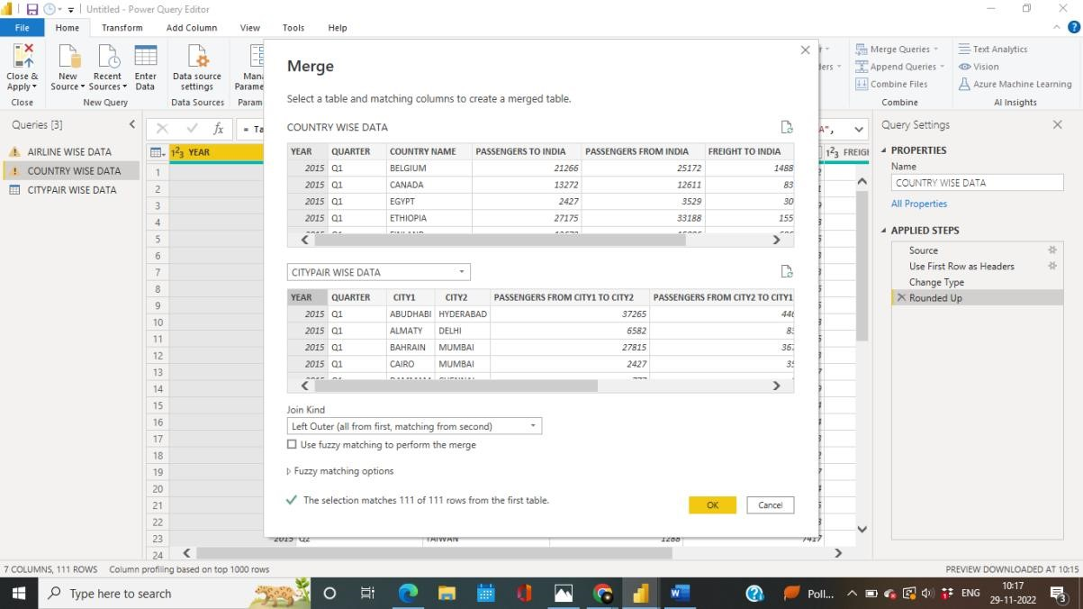

Figure 2.11 Merge Queries

**STEP 12:**

In the merge queries tab merge the “ PASSENGERS TO INDIA” F from airline wise data and country wise data.

**OUTPUT**:

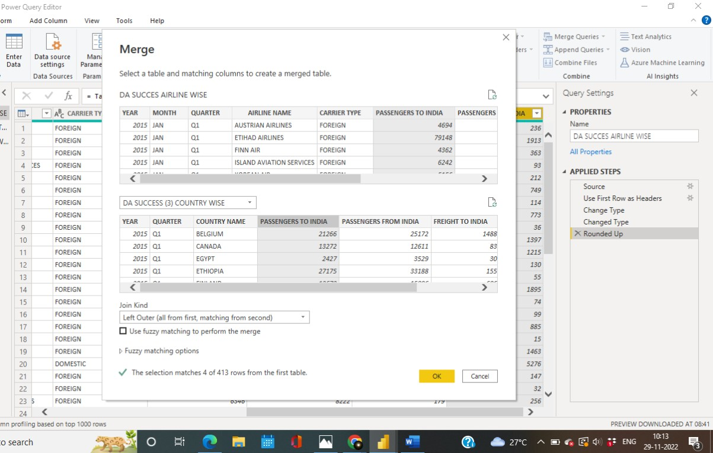

Figure 2.12 Merge Queries

**STEP 13**:

Now load the datasets into the power BI after performing necessary transformations.

**OUTPUT**:

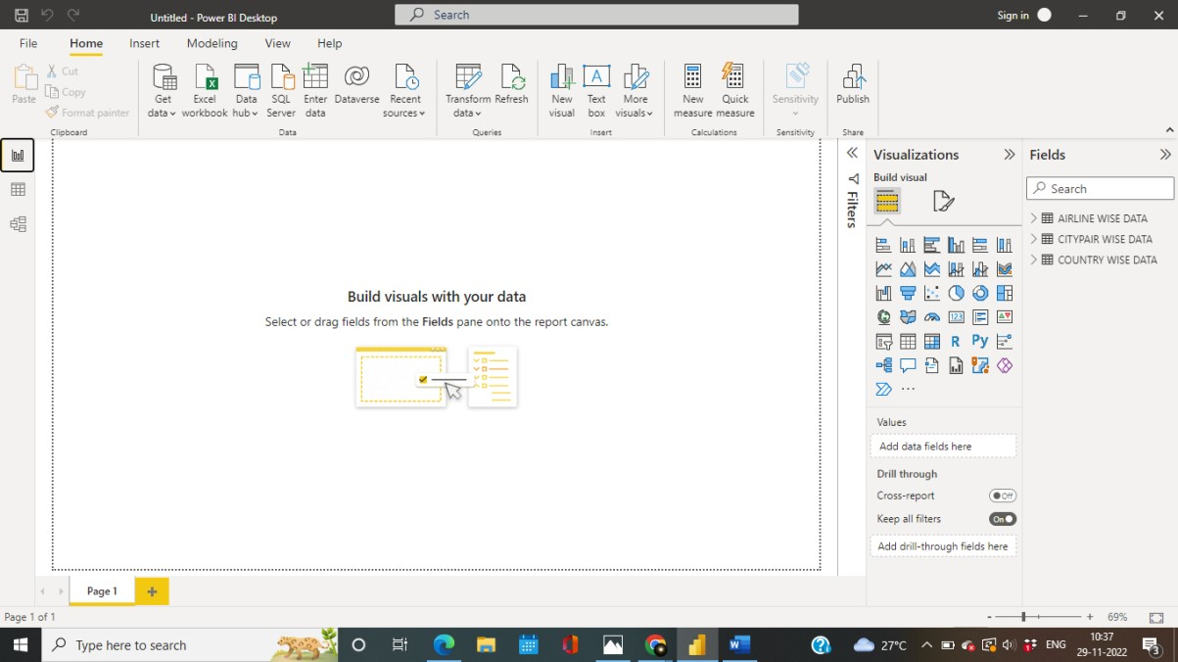

Figure 2.13 Loading The Dataset

**Relationship in data tables**:

For better visualisations, we would need to link some of the many tables that we have. Based on the identical columns, Power BI desktop automatically recognises the relationship in the tables. You may view the relationships as indicated in the following sample if you click Manage relationships or the icon in the sidebar.

**STEP 14:**

In the Model view tab The relationship between the three tables are created and displayed. Thus a relationship is created between the tables.

**OUTPUT**:

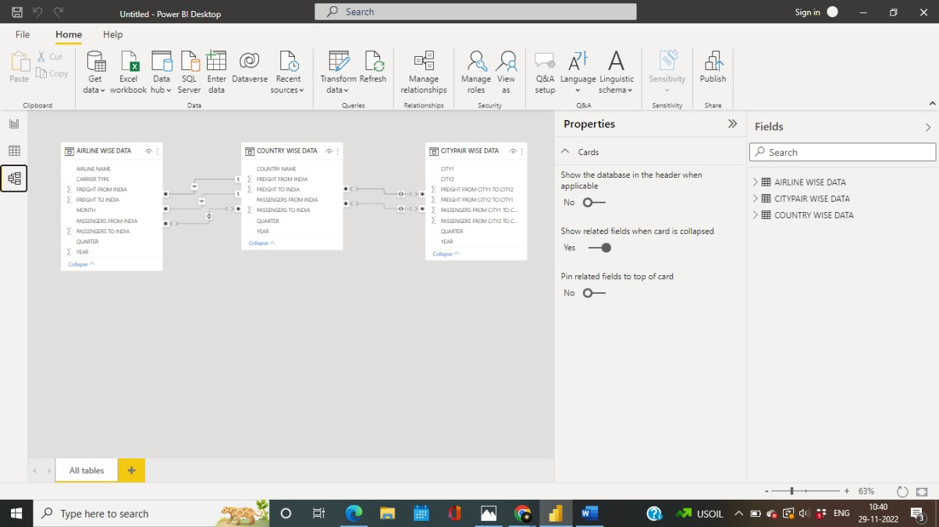

Figure 2.14 Relationship

Finally The analysis of data can be done with the transformed tables.

## DATA DISTRIBUTION USING CHARTS

## DATA MODELLING

* Using solid data, organisations may establish baselines, benchmarks, and goals in order to advance.Data must be organised through data description, data semantics, and data consistency requirements in order for this measuring to be possible. A data model is this abstract model that enables the establishment of links between data items and further development of conceptual models.
* Even if an organisation has a sizable data repository, it is useless if there is no standard to guarantee the fundamental accuracy and interpretability of that data. The best tools to access the data and knowledge of best practises for the data are all certified by a proper data model.

# 

# CHAPTER 3

**DATA ANALYSIS INTERPRETATION**

**Team analysis:**

## DATA ANALYSIS

**Step 1:**

After the preprocessing of the datas, 10 measures are created for the visualization.

**Step 2:**

To calculate the total freights that was carried across the Cities the following measure is used.

Citypair_TotalFreight = sumx(city,CITY[FREIGHT FROM CITY1 TO CITY2]+CITY[FREIGHT FROM CITY2 TO CITY1])

**Step 3:**

To calculate the total passengers who travelled across the cities the below given measure is calculated.

Citypair_TotalPax = sumx(city,CITY[PASSENGERS FROM CITY1 TO CITY2]+CITY[PASSENGERS FROM CITY2 TO CITY1])

**Step 4:**

The Freight that was transported across The country VIA Airlines was calculated.

Total_Freight = sumx(AIRLINE,AIRLINE[FREIGHT FROM INDIA]+AIRLINE[FREIGHT TO INDIA])

**Step 5:**

The passengers who travelled across the country VIA Airlines was calculated.

Total_Pax = sumx(AIRLINE, AIRLINE[PASSENGERS FROM INDIA]+AIRLINE[PASSENGERS TO INDIA])

**Step 6:**

The freights that was transported from a country to other country was calculated.

totalcountry_freight = sumx(COUNTRY,COUNTRY[FREIGHT FROM INDIA]+COUNTRY[FREIGHT TO INDIA]).

**Step 7:**

The passengers who travelled from one country to the other country was calculated.

totalcountry_pax = sumx(COUNTRY,COUNTRY[PASSENGERS FROM INDIA]+COUNTRY[PASSENGERS TO INDIA])

**Step 8:**

To create the total freight visualization,

TOTF = calculate(sum(COUNTRY[FREIGHT FROM INDIA])+sum(COUNTRY[FREIGHT TO INDIA]),all(COUNTRY))

**Step 9:**

To create the Total passengers visualization,

TOTP = calculate(sum(COUNTRY[PASSENGERS FROM INDIA])+sum(COUNTRY[PASSENGERS TO INDIA]),all(COUNTRY))

**Step 10:**

Using the measures 22 charts are formed with the following datas:

* AIRLINEWISE
* COUNTRYWISE
* CITYPAIR WISE

1. **WHAT IS THE TOTAL NUMBER OF PASSENGERS WHO TRAVELLED IN AND OUT OF INDIA**:

STEP1: Select the card visual

Step 2: Drag and drop the total_pax measure in the fields.

Step 3: Change the layout.

**OUT PUT:**

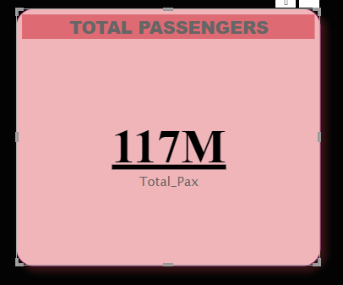

Figure 3.1 Total Passengers

**INFERENCE:**

Therefore 117 million passengers travelled in and out of India.

**2)WHAT IS THE TOTAL FREIGHTS CARRIED IN AND OUT OF INDIA:**

Step 1: Select the card visual

Step 2: Drag and drop the total_freights measure in the fields.

Step 3: Change the layout.

**OUTPUT:**

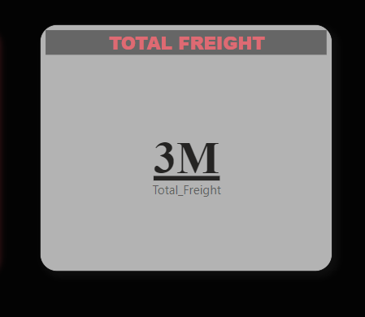

Figure 3.2 Total Freights

**INFERENCE:**

It shows that 3 million goods was carried in and out of India In the years between 2015-2017.

**3) WHAT IS THE TOTAL NUMBER OF FOREIGN AND DOMESTIC PASSENGER BREAK DOWN:**

Step 1: Select Clustered chart column

Step 2: Drag Carrier type in the X-axis

Step 3: Drag the total_pax,passengers from India and Passengers to India in the y axis.

**OUTPUT:**

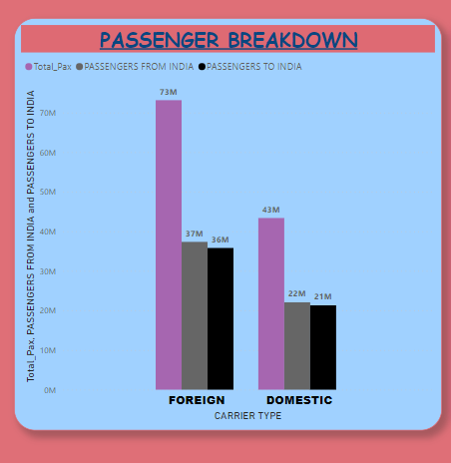

Figure 3.3 Passenger Break down

**INFERENCE:**

* Total passengers across foreign were found to be 731329287.
* In that passengers from India was found to be 37340707.
* Passengers to India was found to be 35798580.
* Total passengers across Domestic areas were found to be 43370445.
* In that passengers from India was found to be 22065392.
* Passengers to India was found to be 21305053.

**4) FIND THE TOTAL NUMBER OF FOREIGN AND DOMESTIC FREIGHT BREAK DOWN:**

Step 1: Select Clustered chart column

Step 2: Drag Carrier type in the X-axis

Step 3: Drag the total_freight,freight from India and freight to India in the y axis.

**OUTPUT:**

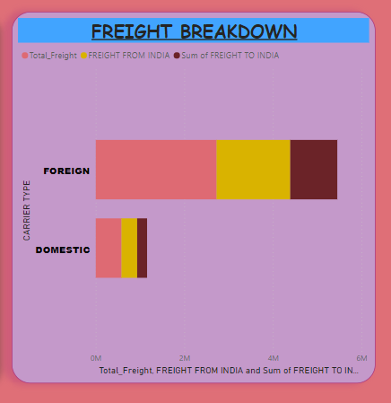

Figure 3.4 Freight Break down

**INFERENCE:**

* The total no of foreign freight breakdown in the total_freight is 2726059 , Freight from India is 1664346 , Freight to India is 1061713.
* The total no of Domestic freight breakdown in the total_freight is 579328 , Freight from India is 355174 , Freight to India is 224154.

**5) FIND THE TOTAL FREIGHT BY YEAR AND QUARTER.**

STEP 1: Select Stacked Column Chart.

STEP 2: Drag the year in the X-asix.

STEP 3: Drag Total_Freight in the Y-axis.

STEP 4: Drag Quarter in the legend.

**OUTPUT:**

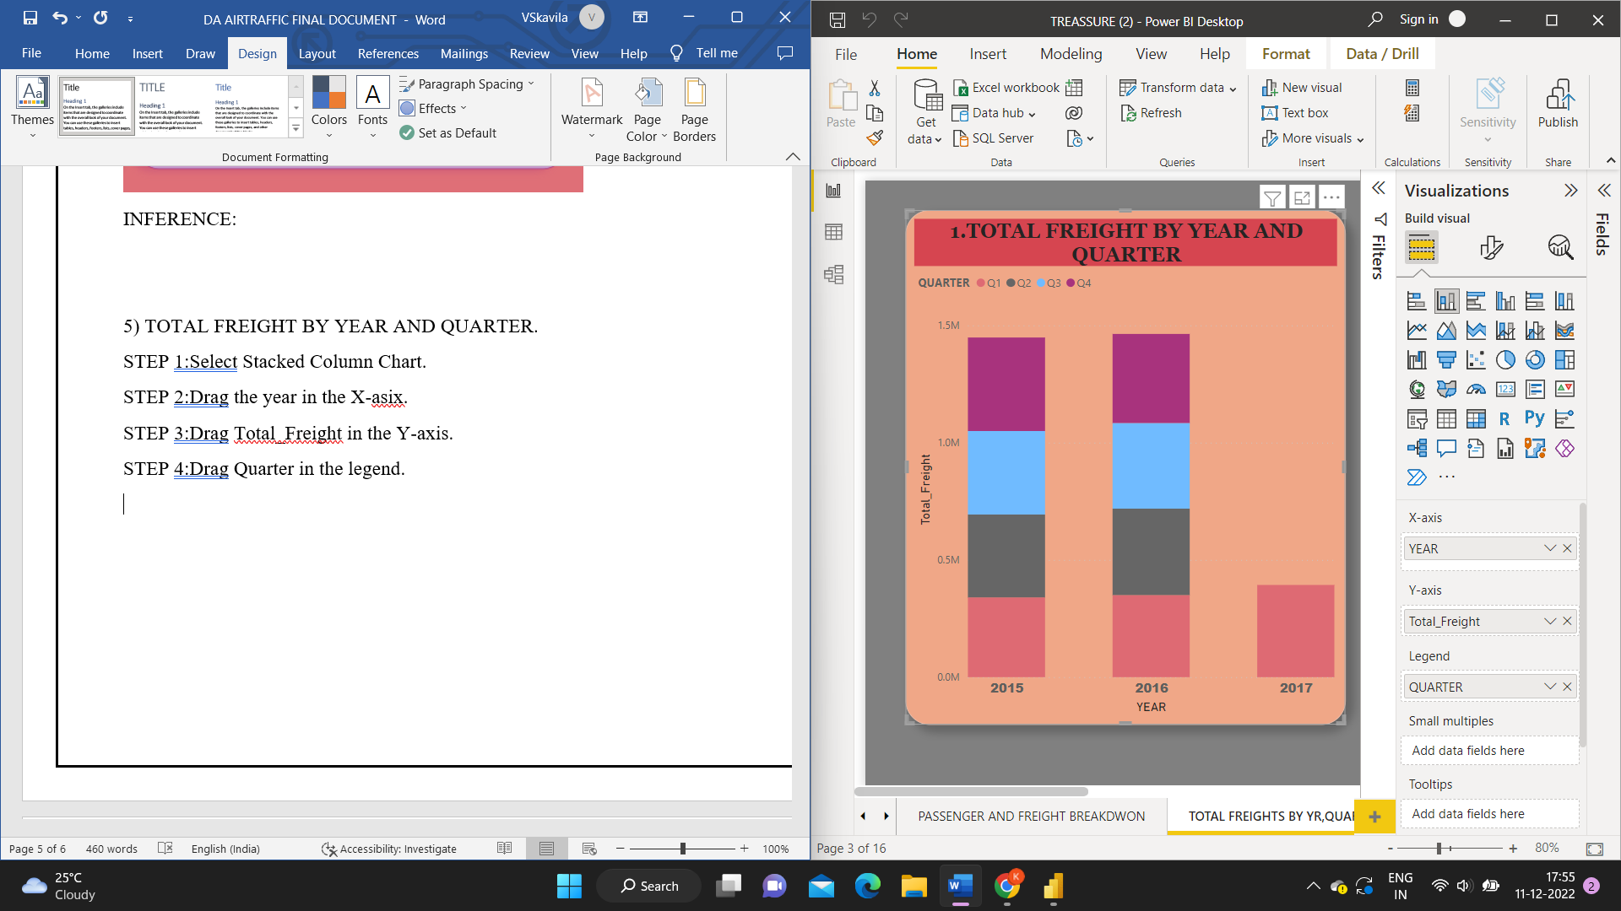

Figure 3.5 Total Freight By Year and quarter

**INFERENCE:**

* The total_freight in the year 2015 is Q1-34015,Q2-353446,Q3-356059,Q4-398855.
* The total_freight in the year 2016 is Q1-350051,Q2-368613,Q3-365308,Q4-379736.
* The total_freight in the year 2017 is Q1-393174.

**6) WHAT IS THE TOTAL FREIGHTS BY CARRIER TYPE.**

STEP 1: Select Pie chart.

STEP 2: Drag carrier type in the legend.

STEP 3: Drag Total_Freight in the values.

**OUTPUT:**

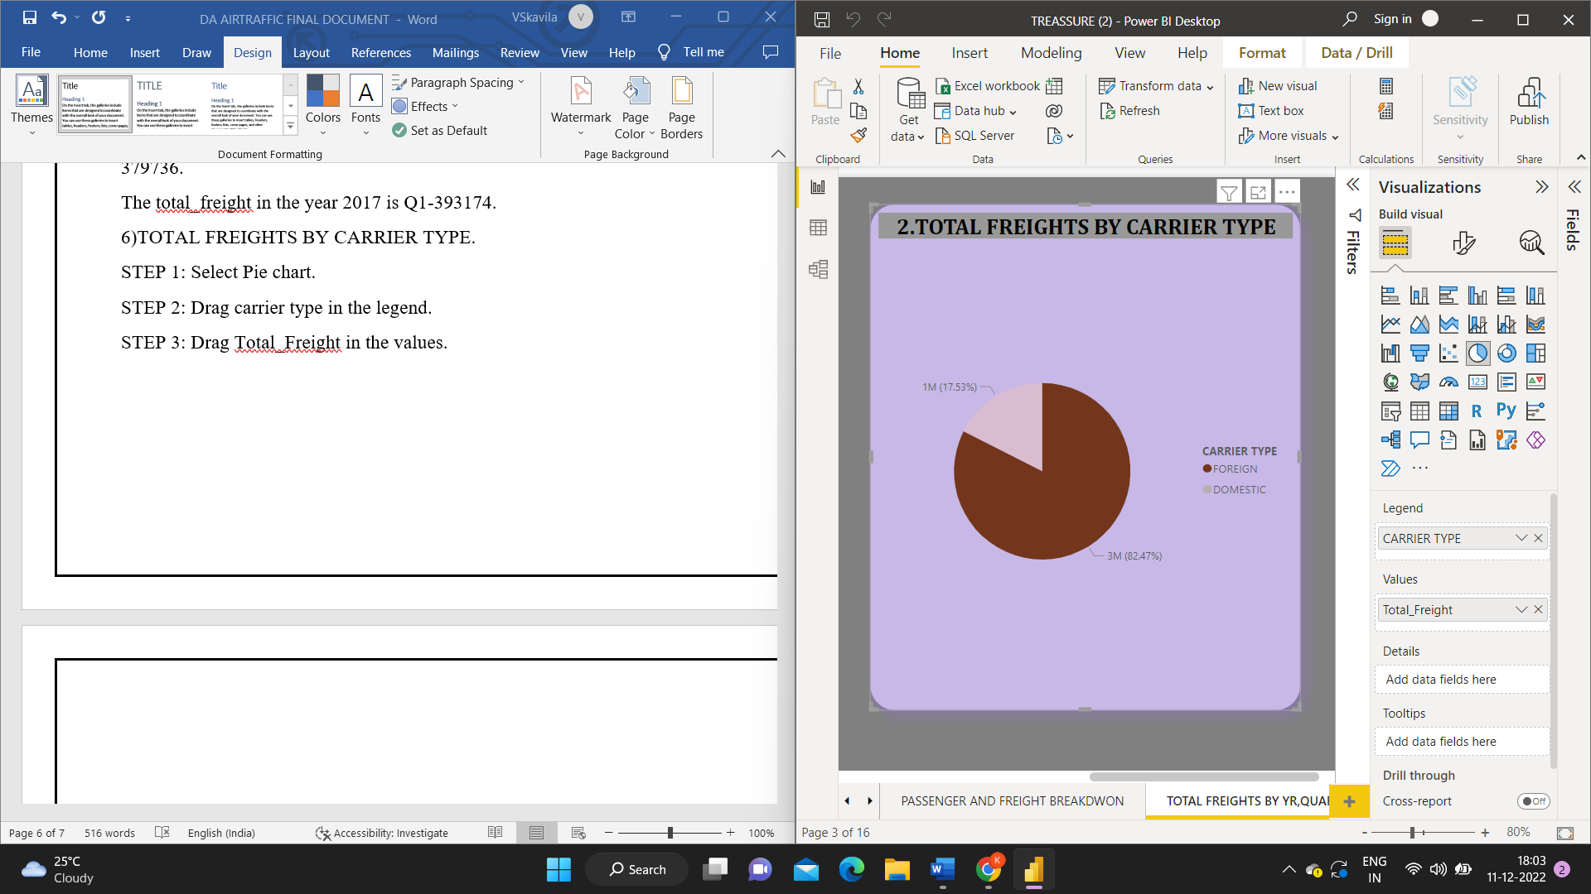

Figure 3.6 Freights by carrier type

**INFERENCE:**

From the analysis it was found that,

* The total freight in the domestic is 579328.
* The total freight in the foreign is 2726059.

**7) FIND THE TOTAL PASSENGERS BY YEAR AND QUARTER.**

STEP 1: Select Clustered Column Chart.

STEP 2: Drag Year in the X-axis.

STEP 3: Drag Total_Pax in the Y-axis.

STEp 4: Drag Quarter in the Legend.

**OUTPUT:**

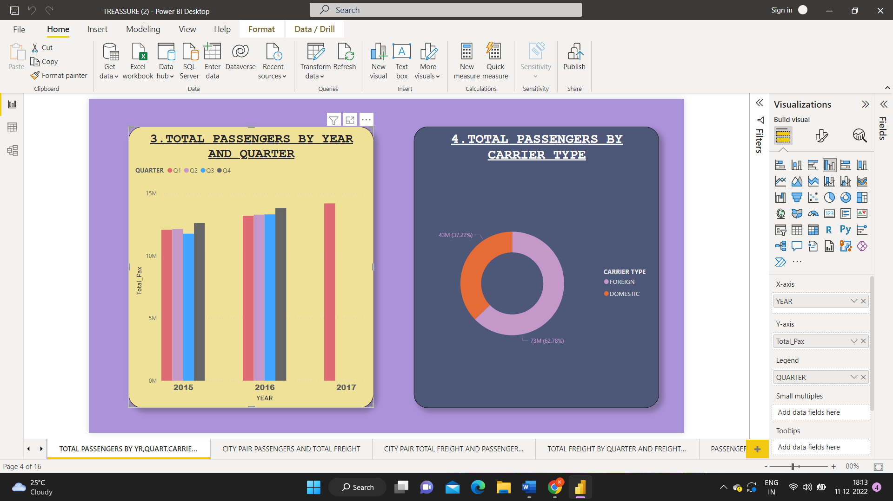

Figure 3.7 Total passengers by year and quarter

**INFERENCE:**

* The Total_Pax in the year 2015 is Q1-12088595,Q2-12153343,Q3-11775585,Q4-12623073.
* The Total_Pax in the Year 2016 is Q1-13214818,Q2-13296993,Q3-133183177,Q4-13835973.
* The total_Pax in the year 2017 is Q1-14202975.

**8) WHAT ARE THE TOTAL PASSENGERS BY CARRIER TYPE.**

STEP 1: Select Donut chart.

STEP 2: Drag Carrier type in the legend.

STEP 3: Drag Total_Pax in the Values.

**OUTPUT:**



Figure 3.8 Total Passengers by carrier type

**INFERENCE:**

Analysing the total passengers by carrier type we found that,

* The total_pax in the Domestic is 43370445.
* The total_Pax in the Foreign is 73139287.

**9)FIND THE PASSENGERS WHO TRAVELLED FROM ONE CITY TO OTHER CITY:**

STEP 1:Select a stacked column chart

STEP 2:Drag City Inside India in X axis

STEP 3:Drag total_pax in Y axis

STEP4:Drag City Outside India In Legend

STEP5: Create a slicer of City inside India,City Outside India and Year in order to get clear insight of the cities and year.

**OUTPUT:**

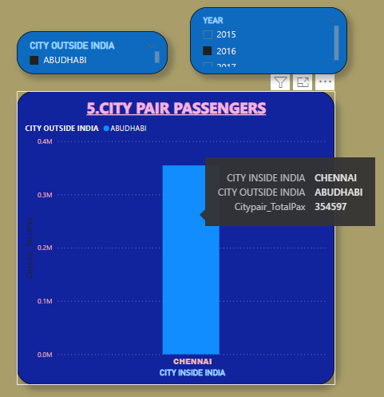

Figure 3.9 City Pair Passengers

**INFERENCE:**

* City outside India and Inside India can be selected according to the choice and can be viewed.For an instance let’s choose City outside India as Singapore and Once the city outside India Is selected the applicable Flights that are available from Singapore to India will be shown accordingly.
* **3337616**  Passengers travelled from Indian cities to Singapore and Vise versa in the year 2015.

**10)FIND THE TOTAL GOODS CARRIED FROM ONE CITY TO OTHER CITY**:

STEP 1: Select a stacked column chart

STEP 2: Drag City Inside India in X axis

STEP 3: Drag TotalCitypair_freight in Y axis

STEP4: Drag City Outside India In Legend

STEP5: Create a slicer of City inside India,City Outside India and Year.

**OUTPUT:**

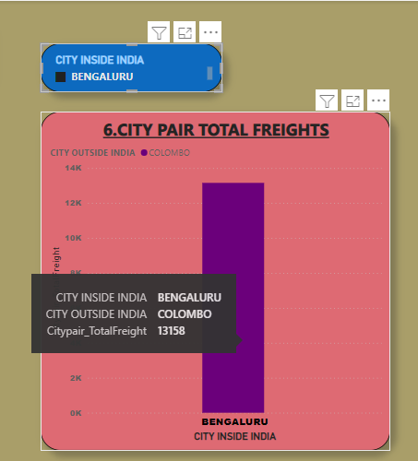

Figure 3.10 City Pair Total Freights

**INFERENCE:**

* City outside India and Inside India can be selected according to the choice and can be viewed.For an instance let’s choose City outside India as Singapore and Once the city outside India Is selected the applicable Flights that are available from Singapore to India will be shown accordingly.
* **97121** goods were transported from Indian cities to Singapore and Vise versa in the year 2015.

**11)FIND THE GOODS THAT WERE CARRIED ACROSS TWO CITIES BY QUARTER**

STEP 1: Select a Clustered column chart

STEP 2: Drag City Inside India in X axis

STEP 3: Drag TotalCitypair_freight in Y axis

STEP4: Drag City Outside India In Legend

STEP 5: Drag Quarter and Year in the small Multiples

STEP 6: Create a slicer of City inside India,City Outside India and Year.

**OUTPUT:**

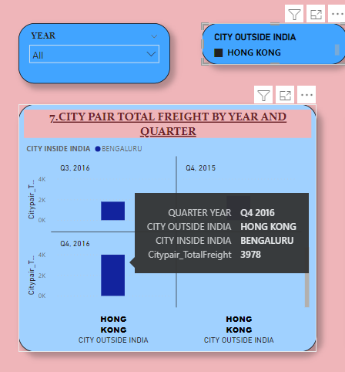

Figure 3.11 Total Freights by year and quarter

* City outside India and Inside India can be selected according to the choice and can be viewed. For an instance let’s choose City outside India as Hong kong and Once the city outside India Is selected the applicable Flights that are available from Hong kong to India will be shown accordingly.
* 3978 freights were imported and exported from Hong kong to Bengaluru in the year 2016.

**12)WHAT IS THE TOTAL NUMBER OF PASSENGERS WHO USED AIR TRANSPORT FROM ONE CITY TO OTHER BY QUARTER**:

STEP 1: Select a Clustered column chart

STEP 2: Drag City Inside India in X axis

STEP 3: Drag Total_pax in Y axis

STEP4: Drag City Outside India In Legend

STEP 5: Drag Quarter and Year in the small Multiples

STEP 6: Create a slicer of City inside India,City Outside India and Year.

**OUTPUT:**

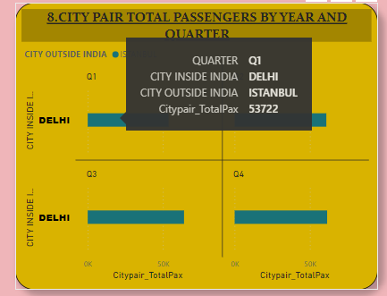

Figure 3.12 Air Transport by Quarter

**INFERENCE:**

* City outside India and Inside India can be selected according to the choice and can be viewed. For an instance let’s choose City outside India as Istanbul and Once the city outside India Is selected the applicable Flights that are available from Istanbul to India will be shown accordingly.
* 53722 passengers travlelled from Istanbul to Delhi and vise versa in the year 2016.

**13)FREIGHTS THAT WERE CARRIED FROM INDIA TO FOREIGN COUNTRIES**

STEP 1:Drag Country Name in X axis

STEP2:Drag Freight from india in Y axis

STEP3:Drag Freight to India in Legend

STEP 4:Create Slicers using year and country name.

**OUTPUT:**

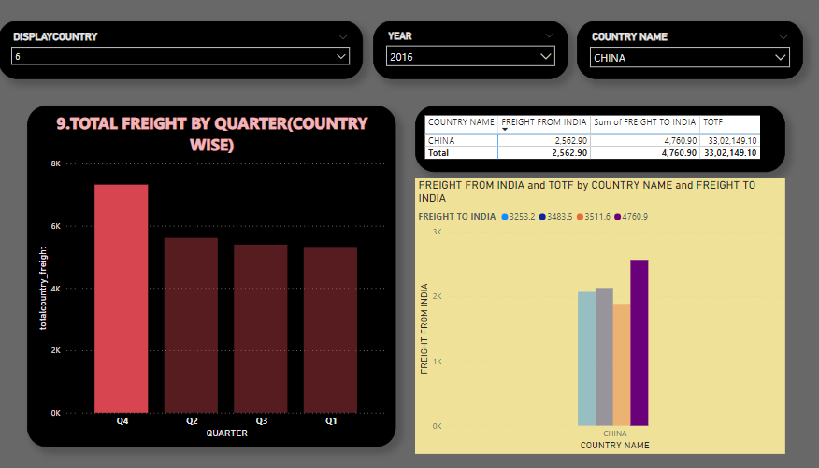

Figure 3.13 Freights carried in and out.

**INFERENCE:**

Totally 33k goods were exported and imported from China to India which is one of the most exporting countries in the world.

**14)TOTAL PASSENGERS WHO MOVED FROM INDIA TO OTHER COUNTRIES BY QUARTER AND YEAR**

STEP 1: Drag Quarter in the legend

STEP 2: Drag total_pax in value column

STEP 3: Create Slicers using year and country name.

**OUTPUT:**

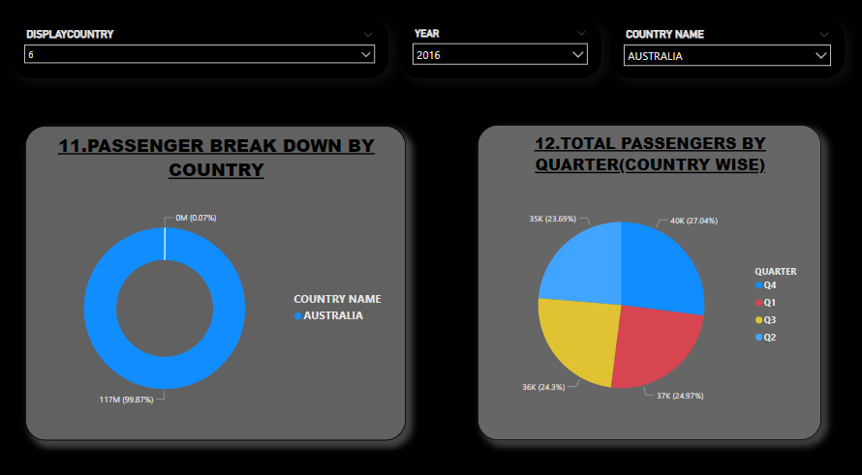

Figure 3.14 Passengers Moved From India

**INFERENCE:**

Country name can chosen accordingly ,for an instance lets choose Australia.

117 million passengers travelled from Australia to India and India to Australia in the year 2016

**15)TOTAL GOODS CARRIED IN AND OUT TO PAKISTAN.**

STEP 1: Select Stacked column chart.

STEP 2: Drag country name in the X-axis.

STEP 3: Drag Freight from India and sum of Freight To India in the Y-axis.

STEP 4: In Filter select the Pakistan in Country Name.

**OUTPUT:**

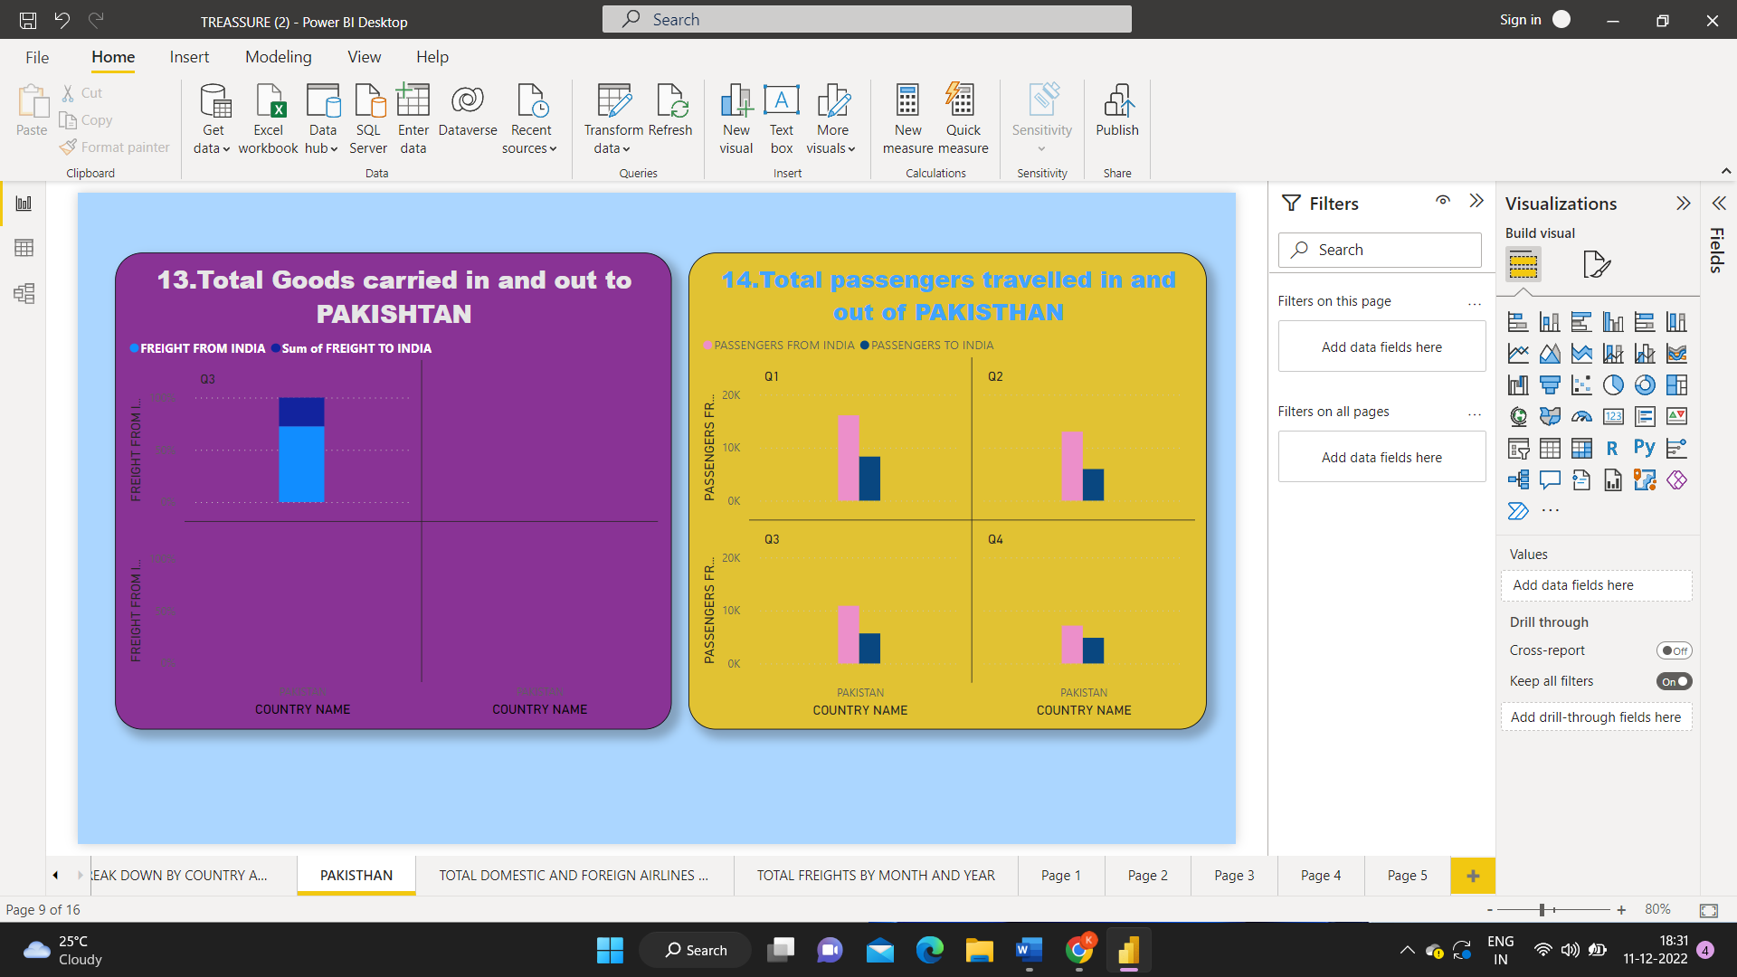

Figure 3.15 Total No of goods

**INFERENCE:**

The percentage of Freight from India is 13.20 and Freight to India is 5.00 in the Q3.

**16) FIND THE TOTAL PASSENGERS TRAVELLED IN AND OUT OF PAKISTAN**.

STEP 1: Select Clustered column chart

STEP 2: Drag country name in the X-aix.

STEP 3: Drag Passengers from India and passengers to India in the Y-axis.

STEP 4: In Filter select the Pakistan in Country Name.

**OUTPUT:**



Figure 3.16 Air transport To Pakisthan

**INFERENCE:**

* The total passengers travelled from India and to India are 16103 and 8416 in Q1.
* The total passengers travelled from India and to India are 13018 and 5963 in Q2.
* The total passengers travelled from India and to India are 10887 and 5673 in Q3.
* The total passengers travelled from India and to India are 7149 and 4849 in Q4.

**17) FIND THE TOTAL DOMESTIC AND FOREIGN AIRLINES.**

STEP 1: Select waterfall chart

STEP 2: Drag carrier type in the Category.

STEP 3: Drag Quarter in the Breakdown.

STEP 4: Drag count of Airline Name in the Y-axis.

**OUTPUT:**

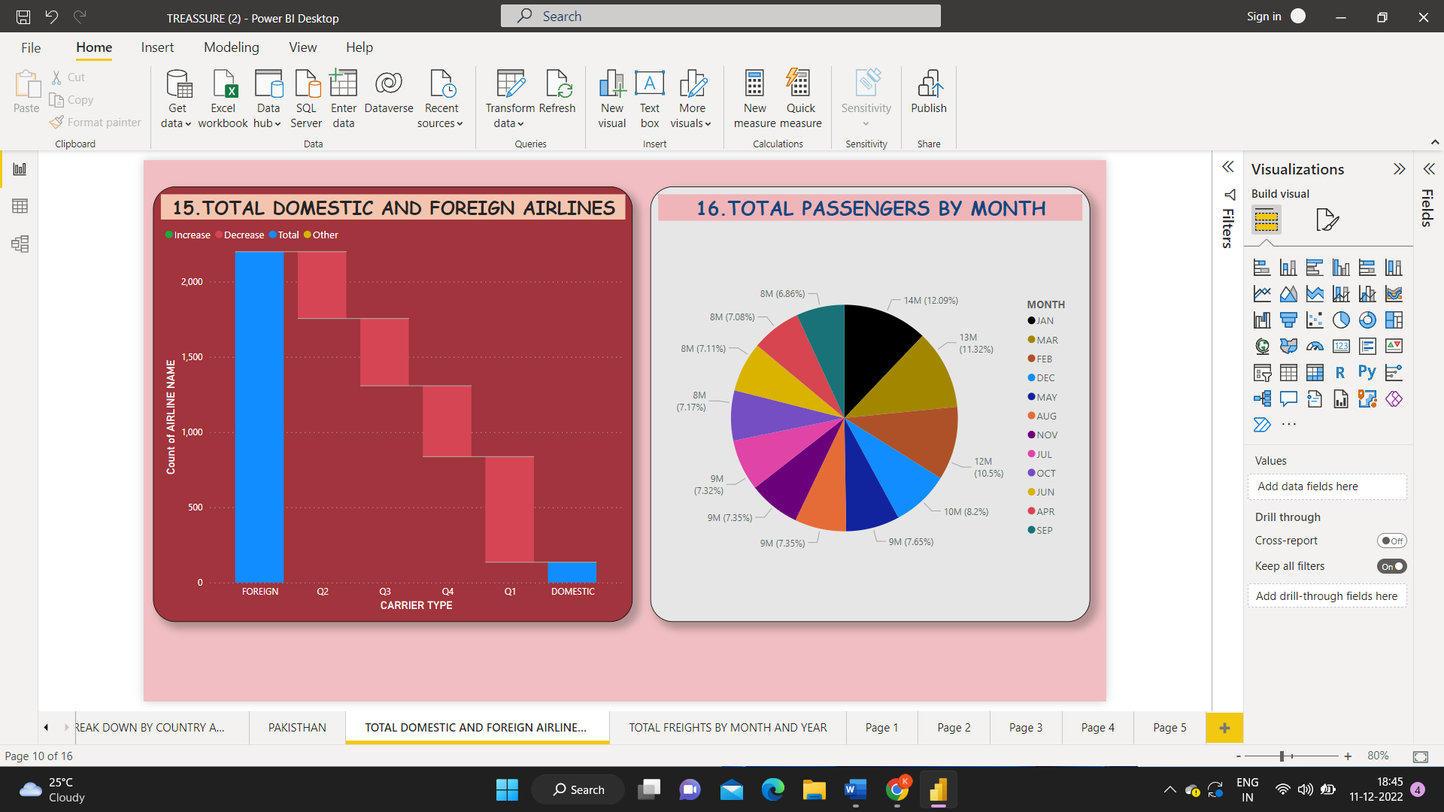

Figure 3.17 Domestic and foreign Airlines

**INFERENCE:**

* The Total no of Airline in the foreign is 2199.
* The Total no of Airline in the Domestic is 135.

**18) FIND THE TOTAL PASSENGERS BY MONTH.**

STEP 1: Select pie chart.

STEP 2: Drag month in the legend.

STEP 3: Drag Total_Pax in the Values.

**OUTPUT:**



Figure 3.18 Total Passengers By month

**INFERENCE:**

The total passengers travelled in the month of JAN – 14082987,

* MAR – 13191365 ,
* FEB – 12232036 ,
* DEC – 9550643 ,
* MAY – 8910960 ,
* AUG – 8568137 ,
* NOV – 8559534 ,
* JUL – 8528486 ,
* OCT – 8348869 ,
* JUN – 8287364 ,
* APR – 8252012 ,
* SEP – 7997339.

**19) FIND THE TOTAL FREIGHTS BY MONTH.**

STEP 1: Select Treemap.

STEP 2: Drag month in the Category.

STEP 3: Drag Total_freight in the Values.

**OUTPUT:**

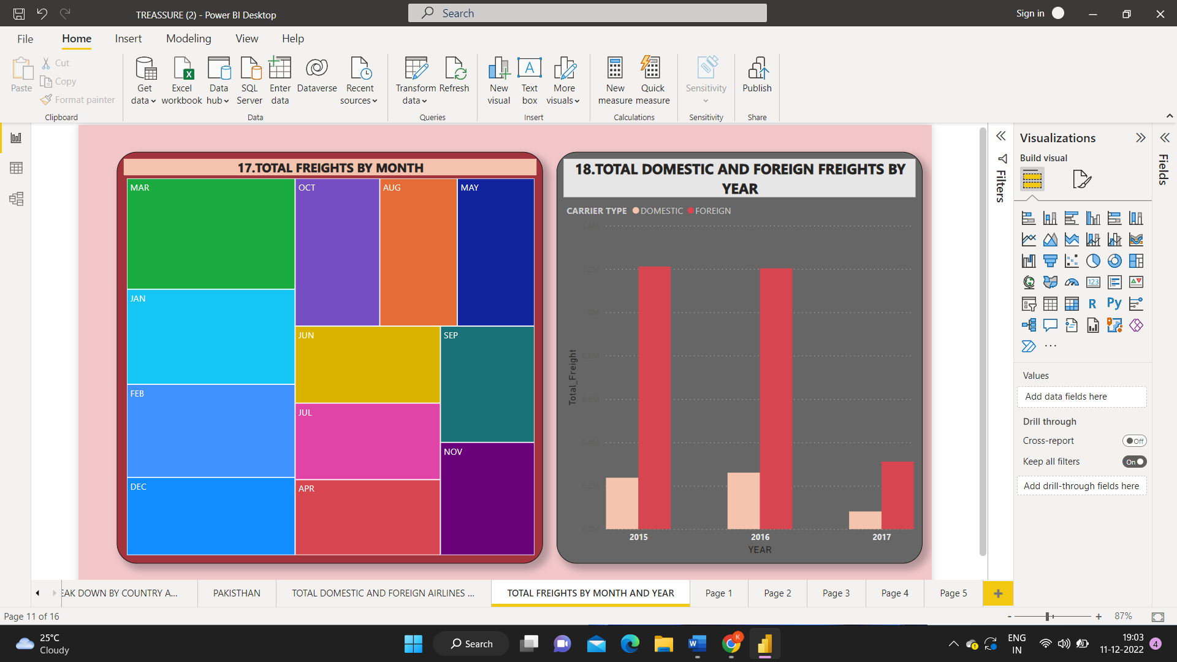

Figure 3.19 Total Freights By Month

**INFERENCE:**

The Total passenger Travelled from India and Travelled to India in the month of

* JAN – 344820 ,
* FEB – 337294 ,
* MAR – 401256 ,
* APR – 235897 ,
* MAY – 245054 ,
* JUN – 241108 ,
* JUL – 239596 ,
* AUG – 246532 ,
* SEP – 235239 ,
* OCT – 269215 ,
* NOV – 227896 ,
* DEC – 281480.

**20) FIND THE TOTAL DOMESTIC AND FOREIGN FREIGHTS BY YEAR.**

STEP 1: Select Clustered Column Chart.

STEP 2: Drag Year in the X-axis.

STEP 3: Drag Total_Freight in the Y-axis.

STEP 4: Drag Carrier Type in the legend.

**OUTPUT:**



Figure 3.20 Total Domestic and Foreign Freights

**INFERENCE:**

* The total freights travelled in the Year of 2015 Domestic is 237176 and foreign is1211329.
* The total freights Travelled in the Year of 2016 domestic is 260563 and foreign is 1203145.
* The total freights Travelled in the Year of 2017 domestic is 81589 and foreign is 311585.

**21) FIND THE TOTAL DOMESTIC AND FOREIGN PASSENGERS BY YEAR.**

STEP 1: Select Stacked bar chart.

STEP 2: Drag Year in the Y-axis.

STEP 3: Drag Total_Pax in the X-axis.

STEP 4: Drag Carrier type in the Legend.

**OUTPUT:**

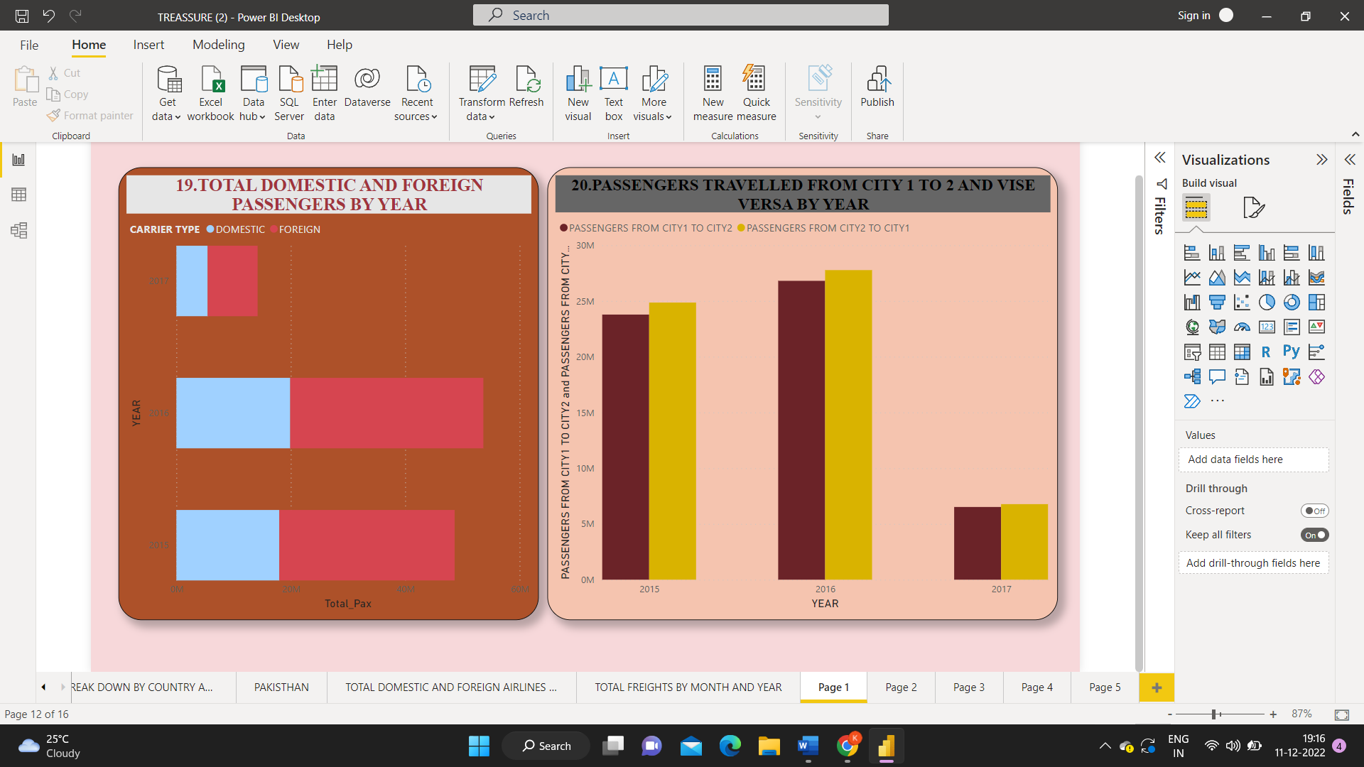 Figure 3.21 Total Domestic and Foreign Freights By Year

**INFERENCE:**

* The total Passengers travelled in the Year of 2015 Domestic 17994183 and foreign 30646413.
* The total Passengers travelled in the Year of 2015 Domestic is 19908133 and foreign 33758028.
* The total Passengers travelled in the Year of 2015 Domestic is 5468129 and foreign is 8734846.

**22) PASSENGERS TRAVELLED FROM CITY 1 TO 2 AND VISE VERSA BY YEAR**.

STEP 1: Select Clustered column chart.

STEP 2: Drag Year in the X-axis.

STEP 3: Drag Passengers from City 1 to city 2 and Passengers from City 2 to City 1 in the Y-axis.

**OUTPUT:**



Figure 3.22 Passengers Travelled From one city to other

**INFERENCE:**

* The total passengers travelled from city1 to city 2 is 23781640 and passengers travelled from city2 to city1 is 24858956 in the year 2015.
* The total passengers travelled from city1 to city 2 is 26807724 and passengers travelled from city2 to city1 is 27771398 in the year 2016.
* The total passengers travelled from city1 to city 2 is 6521248 and passengers travelled from city2 to city1 is 6775745 in the year 2017.

## PUBLISHING DASHBOARD

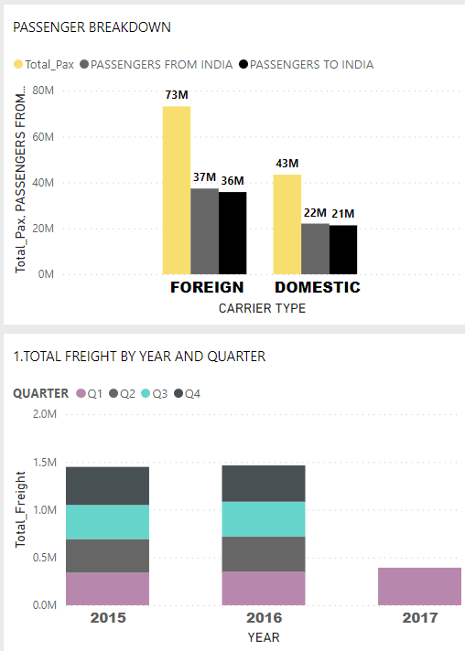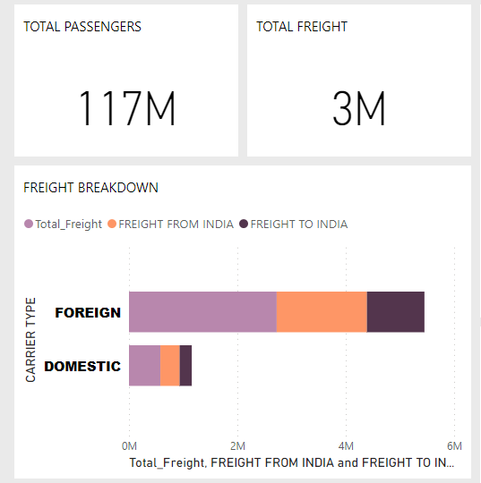

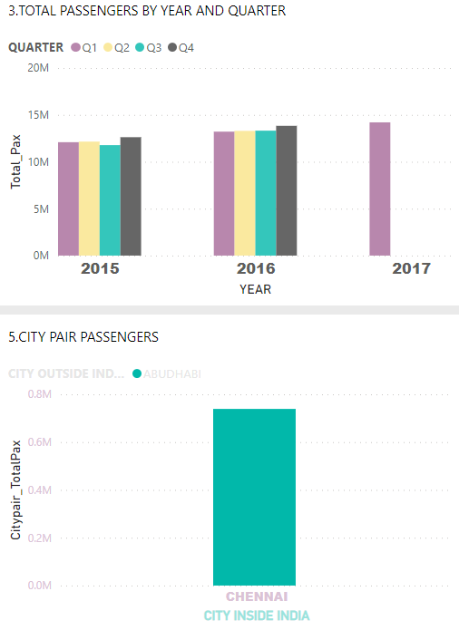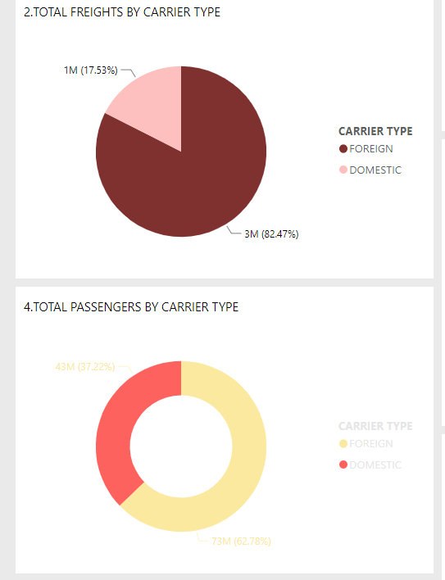  
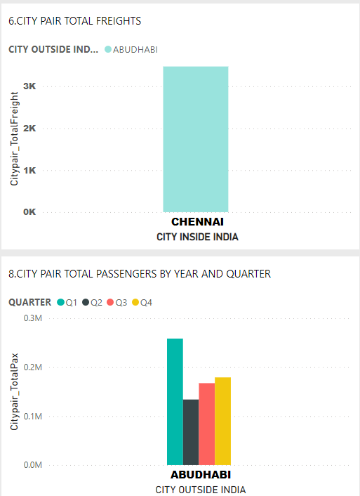 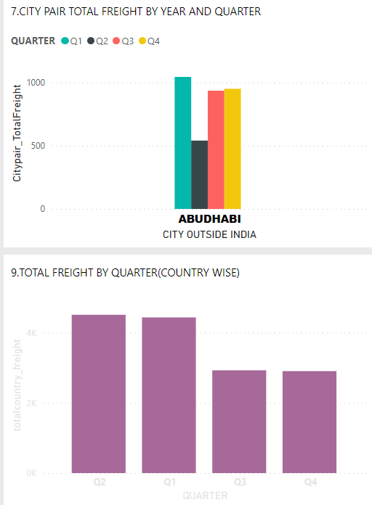

Figure 3.24 Dashboard

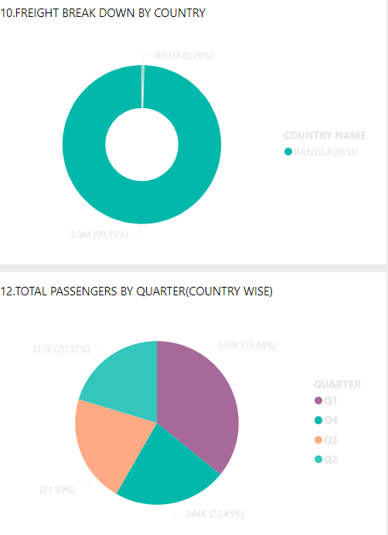 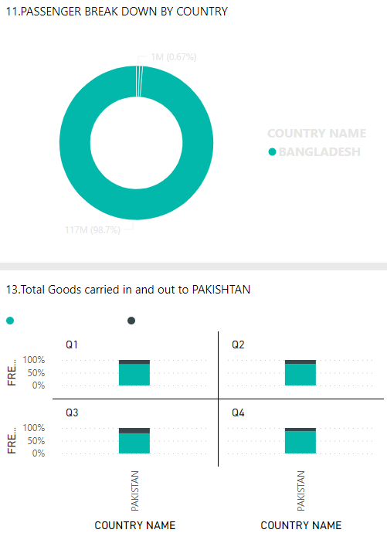

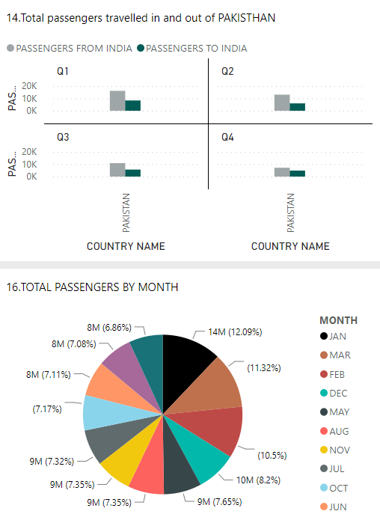 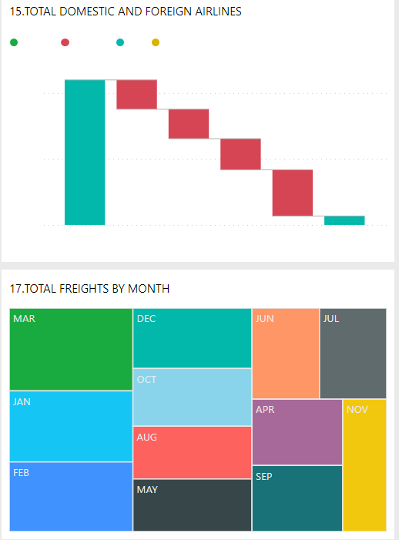

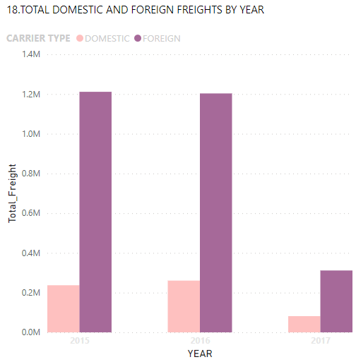 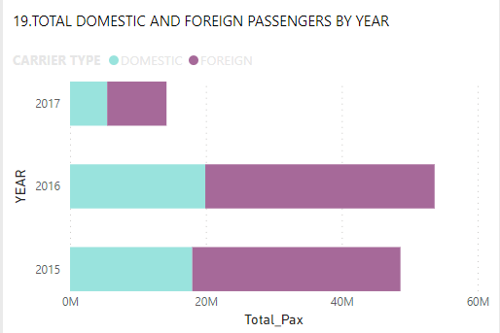

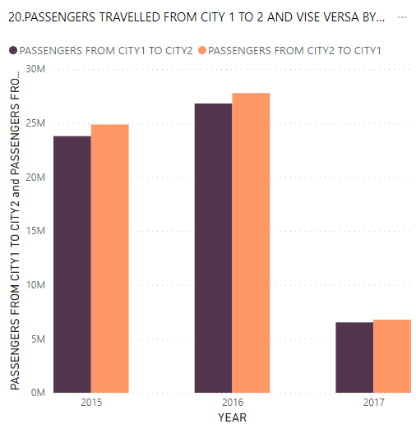

Figure 3.24 Dashboard

## INFERENCES

* The above dashboard represents the AIR TRAFFIC data from the Year 2015-2017 which displays the passenger and freight breakdowns.
* Therefore 117 million passengers travelled in and out of India.
* It shows that 3 million goods was carried in and out of India.
* The report says that domestic travellers were dominated by the foreign travellers.

# CHAPTER 4

# CONCLUSION AND FUTURE WORK

* With an average annual growth rate of 16.3% between 2000 and 2015, India is the third-largest civil aviation sector in the world as of 2017.
* Our nation had 131 million passengers in air transportation in 2016.
* Despite this development, most of the nation's aviation potential is still untapped. The data was difficult to handle, analyse, and display due to its size.
* Using the developed dash board, it is possible to have a thorough understanding of the aviation traffic in our nation.
* To learn more about the nation's aviation traffic, this research may be expanded using the present year and the years to come.

# REFERENCES

* ["India crowned world's fastest growing aviation market in 2015 as economy takes off, The Telegraph, 1 January 2016"](https://www.telegraph.co.uk/finance/economics/12077311/India-crowned-worlds-fastest-growing-aviation-market-in-2015-as-economy-takes-off.html). [Archived](https://web.archive.org/web/20180110005634/http:/www.telegraph.co.uk/finance/economics/12077311/India-crowned-worlds-fastest-growing-aviation-market-in-2015-as-economy-takes-off.html) from the original on 10 January 2018. Retrieved 4 April 2018.
* Eden, Paul E. (21 December 2015). [The World's Greatest Civil Aircraft: An Illustrated History](https://books.google.com/books?id=Rms9CwAAQBAJ&q=allahabad+naini+mail&pg=PT8). Amber Books. [ISBN](https://en.wikipedia.org/wiki/ISBN_(identifier)) [9781782742722](https://en.wikipedia.org/wiki/Special:BookSources/9781782742722).
* [Regional Connectivity Scheme – UDAN](https://web.archive.org/web/20170401144401/http:/www.aai.aero/public_notices/aaisite_test/Final-Regional-Connectivity-Scheme(RCS)311016.pdf) (PDF) (Report). [Ministry of Civil Aviation – Government of India](https://en.wikipedia.org/wiki/Ministry_of_Civil_Aviation_(India)). October 2016. Archived from [the original](http://www.aai.aero/public_notices/aaisite_test/Final-Regional-Connectivity-Scheme(RCS)311016.pdf) (PDF) on 1 April 2017. Retrieved 31 March 2017.
* [Participating unserved UDAN-RCS airports](http://www.airportsindia.org.in/public_notices/aaisite_test/LIST-UNSERVED-AS-ON22NOV16.pdf) [Archived](https://web.archive.org/web/20171201035729/http:/www.airportsindia.org.in/public_notices/aaisite_test/LIST-UNSERVED-AS-ON22NOV16.pdf) 1 December 2017 at the [Wayback Machine](https://en.wikipedia.org/wiki/Wayback_Machine" \o "Wayback Machine), [Airport Authority of India](https://en.wikipedia.org/wiki/Airport_Authority_of_India), Nov 2016.
* [State police to stand guard at Airports under UDAN scheme](https://economictimes.indiatimes.com/industry/transportation/airlines-/-aviation/state-police-to-stand-guard-at-airports-under-udan-scheme/articleshow/61886945.cms) [Archived](https://web.archive.org/web/20171202150934/https:/economictimes.indiatimes.com/industry/transportation/airlines-/-aviation/state-police-to-stand-guard-at-airports-under-udan-scheme/articleshow/61886945.cms) 2 December 2017 at the [Wayback Machine](https://en.wikipedia.org/wiki/Wayback_Machine" \o "Wayback Machine), [Economic Times](https://en.wikipedia.org/wiki/The_Economic_Times), 2 December 2015.
* ["In-principle approval for 19 greenfield airports given: Raju, Times of India, 20 December 2017"](https://timesofindia.indiatimes.com/business/india-business/in-principle-approval-for-19-greenfield-airports-given-raju/articleshow/62192197.cms). [Archived](https://web.archive.org/web/20180518105345/https:/timesofindia.indiatimes.com/business/india-business/in-principle-approval-for-19-greenfield-airports-given-raju/articleshow/62192197.cms) from the original on 18 May 2018. Retrieved 22 December 2017.
* Vijay Mohan. [Army’s helicopter repair hub likely to come up in Hisar](http://www.tribuneindia.com/news/nation/army-s-helicopter-repair-hub-likely-to-come-up-in-hisar/274173.html) [Archived](https://web.archive.org/web/20171202203155/http:/www.tribuneindia.com/news/nation/army-s-helicopter-repair-hub-likely-to-come-up-in-hisar/274173.html) 2 December 2017 at the [Wayback Machine](https://en.wikipedia.org/wiki/Wayback_Machine" \o "Wayback Machine), [The Tribune](https://en.wikipedia.org/wiki/The_Tribune_(Chandigarh)), 1 August 2016.
* [Haryana to develop international airport at Hisar](http://www.travelbizmonitor.com/Ministry/haryana-govt-to-develop-international-airport-at-hisar-30068) [Archived](https://web.archive.org/web/20171019112209/http:/www.travelbizmonitor.com/Ministry/haryana-govt-to-develop-international-airport-at-hisar-30068) 19 October 2017 at the [Wayback Machine](https://en.wikipedia.org/wiki/Wayback_Machine" \o "Wayback Machine), [TravelBizMonitor](http://www.travelbizmonitor.com/) [Archived](https://web.archive.org/web/20171129150531/http:/www.travelbizmonitor.com/) 29 November 2017 at the [Wayback Machine](https://en.wikipedia.org/wiki/Wayback_Machine" \o "Wayback Machine), Retrieved in March 2016.
* ["GoI AAI's RCS UDAN document (final version), October 2016"](https://web.archive.org/web/20170606122530/http:/www.aai.aero/public_notices/aaisite_test/Final-Regional-Connectivity-Scheme(RCS)311016.pdf) (PDF). AAI.aero. Archived from [the original](http://www.aai.aero/public_notices/aaisite_test/Final-Regional-Connectivity-Scheme(RCS)311016.pdf) (PDF) on 6 June 2017. Retrieved 9 January 2018.
* ["Ude Desh Ka Aam Naagrik : Civil Aviation Ministry's Regional Connectivity Scheme "UDAN" Launched Today"](http://pib.nic.in/newsite/PrintRelease.aspx?relid=151850). [Press Information Bureau](https://en.wikipedia.org/wiki/Press_Information_Bureau). [Government of India](https://en.wikipedia.org/wiki/Government_of_India). 21 October 2016. [Archived](https://web.archive.org/web/20171106001614/http:/pib.nic.in/newsite/PrintRelease.aspx?relid=151850) from the original on 6 November 2017. Retrieved 22 November 2017.